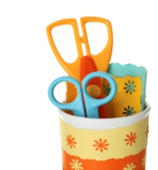  

**Scrapbooking and Cardmaking Day**

**Saturday, April 21, 2012**

**10 am – 4 pm**

**Chenango Forks High School Cafeteria**

**Bring your crafty family and friends,**

**your crafting projects & supplies**

**~ Enjoy 6 hours of dedicated crafting time**

**~ Light lunch ~ Thank you gift**

**$12 per person**

**Basket Raffles, 50/50 Raffle, Bake Sale, Mets vs. Yankees Raffle**

For more information, Call Donna @ 607-204-0611 or 607-648-8161

- - - - - - - - - - - - - - - - - - - - - - - - - - - - - - - - - - - - - - - - - - - - - - - - -

Please return registration form to: Donna Schulz, 2518 NYS Rt. 12, Chenango Forks, NY 13746

Checks payable to CFCA

Name:

Address:

Phone: Email (optional):

No. attending x $12 amt enclosed

Additional Attendees:

Vendors Wanted for this event:

Do you sell Avon, Pampered Chef, Lia Sophia, etc? Would you like to be a vendor at our event?

We are charging $15.00 per table.  Send in this form with check payable to "CFCA" to reserve your spot.

The first vendor reservation received for a particular company will be selected to participate.

Name Phone

Email I am a Vendor for

Proceeds benefit 